**05. AWS X-Ray Deploy on EKS Cluster as DaemonSet**

--- Reference - <https://github.com/stacksimplify/aws-eks-kubernetes-masterclass/tree/master/13-Microservices-Distributed-Tracing-using-AWS-XRay-on-EKS>

--- in this lesion, we are going to create IAM permission for AWS x-ray daemon to run on EKS cluster and send x-ray traces from aws EKS cluster to the aws x-ray service.

**Create IAM permissions for AWS X-Ray daemon**

**# Template**

--- **eksctl create iamserviceaccount \**

**--name service_account_name \**

**--namespace service_account_namespace \**

**--cluster cluster_name \**

**--attach-policy-arn arn:aws:iam::aws:policy/AWSXRayDaemonWriteAccess \**

**--approve \**

**--override-existing-serviceaccounts**

**# Replace Name, Namespace, Cluster Info (if any changes)**

--- **eksctl create iamserviceaccount \**

**--name xray-daemon \**

**--namespace default \**

**--cluster eksdemo1 \**

**--attach-policy-arn arn:aws:iam::aws:policy/AWSXRayDaemonWriteAccess \**

**--approve \**

**--override-existing-serviceaccounts**

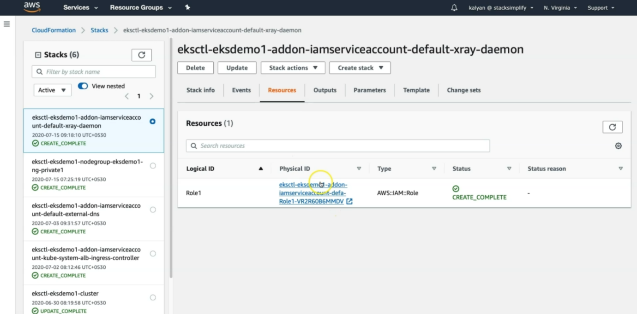

--- under resource section, it will find the IAM role, it had created.

**Verify Service Account and AWS IAM Role**

**# List k8s Service Accounts**

--- **kubectl get sa**



**# Describe Service Account (Verify IAM Role annotated)**

--- **kubectl describe sa xray-daemon**

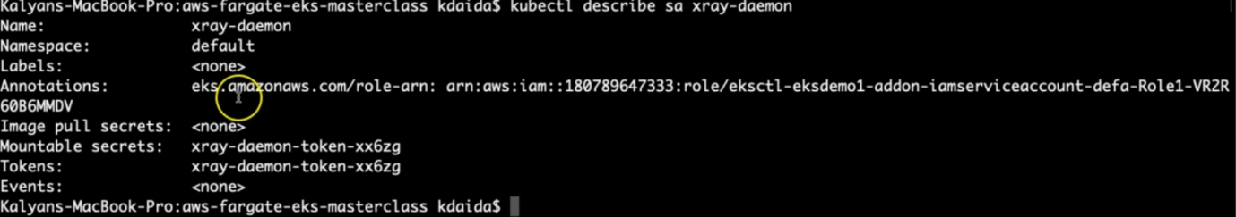

--- **note** – in the service account, our IAM role arn is annotated.

**# List IAM Roles on eksdemo1 Cluster created with eksctl**

--- **eksctl get iamserviceaccount --cluster eksdemo1**



--- **note** – it will give us the all the service accounts created inside of this cluster.

**Update IAM Role ARN in xray-k8s-daemonset.yml**

--- Get AWS IAM Role ARN for xray-daemon

**# Get AWS IAM Role ARN**

--- **eksctl get iamserviceaccount xray-daemon --cluster eksdemo1**

--- Update xray-k8s-daemonset.yml

--- File Name: **kube-manifests/01-XRay-DaemonSet/xray-k8s-daemonset.yml**

apiVersion: v1

kind: ServiceAccount

metadata:

  labels:

    app: xray-daemon

  name: xray-daemon

  namespace: default

  # Update IAM Role ARN created for X-Ray access

  annotations:

    eks.amazonaws.com/role-arn: arn:aws:iam::180789647333:role/eksctl-eksdemo1-addon-iamserviceaccount-defa-Role1-20F5AWU2J61F

**Deploy X-Ray DaemonSet on our EKS Cluster**

**# Deploy**

--- **kubectl apply -f kube-manifests/01-XRay-DaemonSet/xray-k8s-daemonset.yml**

**# Verify Deployment, Service & Pod**

--- **kubectl get deploy,svc,pod**

**# Verify X-Ray Logs**

--- **kubectl logs -f <X-Ray Pod Name>**

--- **kubectl logs -f xray-daemon-phszp**

**# List & Describe DaemonSet**

--- **kubectl get daemonset**

--- **kubectl describe daemonset xray-daemon**